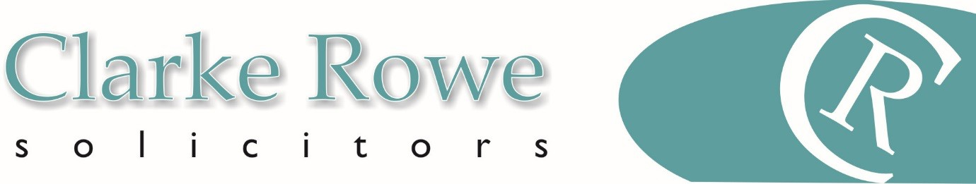
Residential Property

Re-mortgage of a Property
HOW LONG WILL MY RE-MORTGAGE TAKE
How long it will take from your offer of a re-mortgage until completion will depend on a number of factors. A typical process takes between 4 – 8 weeks although it can be quicker or slower, depending on circumstances.
HOW MUCH WILL MY REMORTGAGE COST
For a re-mortgage up to the value of £350,000 the indicative costs are set out in the table below. For any re- mortgage over £350,000 we would need to prepare a bespoke quotation, which we can do very quickly once we have spoken to you and have further details of the proposed transaction.
Re-Mortgage – Property Value up to £350,000
 | (£) | VAT (£)20%
Legal Fees Freehold | 850 | 170
Leasehold Element | 150 | 30
TOTAL LEGAL FEES | 850 | 170

Disbursements – these may vary according to individual circumstances, we will always confirm precise figures
 | (£) | VAT (£)20%
Search Report Bundle | approx.. 350 | 60.00
Office Copy Entries (per title document) | 7 | 1.40
Bankruptcy Search (per person) | 6 | 1.20
HM Land Registry Search | 7 | 1.40
ID Administration Fee (per name) | 25 | 5.00
Bank Charge Administration Fee | 20 | 4.00
Bank charge transfer fee | 17 | 3.40

Our fee assumes that:
- This is a standard transaction and that no unforeseen matters arise including for example (but not limited to) a defect in title which requires remedying prior to completion or the preparation of additional documents ancillary to the main transaction
- The transaction is concluded in a timely manner and no unforeseen complications arise
- All parties to the transaction are co-operative and there is no unreasonable delay from third parties providing documentation
- No indemnity policies are required. Additional disbursements may apply if indemnity policies are required These costs are indicative only and we will always provide an estimate prior to starting work.
Factors that may affect the cost of the transaction:
- The value of the property
- Whether there are multiple owners
- Whether the property is part of a shared ownership scheme
- Whether the property was purchased under right to buy
The key stages of your matter:
The precise stages involved in a re-mortgage vary according to the circumstances, however, below we have suggested some key stages that you may wish to include:
- Taking your instructions and giving you initial advice
- Going through the mortgage company’s instructions
- Investigating title

- Giving you advice on all documents and information received
- Obtaining a redemption statement
- Agreeing a completion date and requesting funds
- Arranging for all monies needed to be received from the lender
- Completing the re-mortgage and redeeming the previous mortgage
- Registering the new mortgage

Please call for advice and a more specific estimate of costs – 01202 307940

