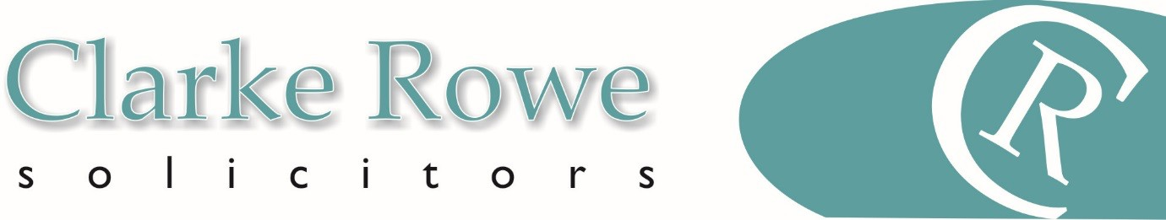

Residential Property

Purchase of a Freehold or Leasehold Property

HOW LONG WILL MY HOUSE PURCHASE TAKE
How long it will take from your offer being accepted until you can move in to your house will depend on a number of factors. The typical process takes between 6 – 10 weeks. It can be quicker or slower, depending on the parties in the chain. For example, if you are a first-time buyer, purchasing a new build property with a mortgage in principle, it could take several months as the timing will depend on how long it takes to build and finish your new home.

HOW MUCH WILL IT COST
Typical (indicative only) cost of a Freehold or Leasehold Property Purchase for a first time buyer:

Purchase Costs – Property Value £350,000 (England)
 | (£) | VAT (£) 20% | TOTALS
Legal Fees | 1535.00 | 307.00 | 1842.00
Leasehold Element | 250.00 | 50.00 | 300.00

Disbursements – these will vary according to individual circumstances and the property price, we will always confirm figures
 | (£) | VAT (£)
Search Report Bundle | approx.. 350.00 | 70.00
Bankruptcy Search (per person) | 6.00 | 1.20
Bank Transfer Fee (per transfer) | 17.00 | 3.40
HM Land Registry Search | 7.00 | 1.20
Land Registry Fee | 150.00 | 0
ID Administration Fee (per name) | 25.00 | 5.00
Bank Charge Administration Fee | 20.00 | 4.00
Stamp Duty Form Administration Fee | 75.00 | 15.00
Stamp Duty Land Tax (SDLT) approx.. | TBA | 0

These costs are indicative and we will always provide an estimate prior to starting work.

LAND OR PROPERTY TRANSACTIONS TAX
This is a tax on property transactions. It varies according to the price of the property purchased and may increase substantially for more expensive properties or if this is a second home or buy to let property. The links below take you to a tax calculator on the relevant government website according to which country the property is located:
- England – you pay Stamp Duty Land Tax (SDLT) if you buy a property in England: https://www.tax.service.gov.uk/calculate-stamp-duty-land-tax/#/intro.
- Wales – you pay Land Transaction Tax (LTT): https://lttcalculator.wra.gov.wales/
We can of course advise you on these costs.

Our fees include:
- Taking your instructions and giving you initial advice
- Checking finances are in place to fund the purchase and contacting the lender’s solicitors if needed
- Receiving and advising on contract documents
- Carrying out searches
- Obtaining further planning documentation if required
- Making any necessary enquiries of seller’s solicitor
- Giving you advice on all documents and information received

- Going through conditions of mortgage offer with you
- Sending final contract to you for signature
- Agreeing completion date (date from which you own the property)
- Exchanging contracts and notifying you that this has happened
- Arranging for all monies needed to be received from lender and you
- Completing purchase
- Dealing with payment of Stamp Duty Land Tax (SDLT)
- Registration of title

Our fees assume that:
- This is a standard transaction and that no unforeseen matters arise including for example (but not limited to) a defect in title which requires remedying prior to completion or the preparation of additional documents ancillary to the main transaction
- The transaction is concluded in a timely manner and no unforeseen complications arise
- All parties to the transaction are co-operative and there is no unreasonable delay from third parties providing documentation
- No indemnity policies are required. Additional disbursements may apply if indemnity policies are required

Factors that will affect the cost of the transaction:
- The value of the property
- Whether there are multiple owners
- Whether the property is part of a shared ownership scheme
- Whether the property was purchased under right to buy
- Whether you are a first-time buyer
- Whether the property is new build
- Whether the property requires first registration of title
- Whether the property is a primary residence, buy to let or second/holiday home
- Whether you are using a help to buy scheme and whether it is an equity loan or ISA
- Whether you purchased at auction
- Whether the property has been repossessed

The key stages of your matter:
The precise stages involved in the purchase of a residential property vary according to the circumstances, however, below we have highlighted key stages of a transaction:
- Taking your instructions and giving you initial advice
- Checking finances are in place to fund purchases and contacting lender’s solicitors if needed
- Receiving and advising on contract documents
- Carrying out searches
- Obtaining further planning documentation if required
- Making any necessary enquiries of seller’s solicitor
- Giving you advice on all documents and information received
- Going through conditions of mortgage offer with you
- Sending final contract to you for signature
- Drafting the transfer
- Advising you on joint ownership
- Obtaining pre-completion searches
- Agreeing completion date (date from which you own the property)
- Exchanging contracts and notifying you that this has happened
- Arranging for all monies needed to be received from lender and you
- Completing purchase
- Dealing with payment of Stamp Duty Land Tax (SDLT)
- Dealing with application for registration at Land Registry

Please call for advice and an individual estimate of costs – 01202 307940

